REPUBLIQUE DU CAMEROUN

PAIX -TRAVAIL-PATRIE

*****************

INSTITUT AFRICAIN D’INFORMATIQUE

*****************

BP : 13 719 Yaoundé (Cameroun)

Tel: (237) 22 72 99 57 / (237) 22 72 99 58

Site Web: [www.iaicameroun.com](http://www.iaicameroun.com)

REPUBLIQUE OF CAMEROON

PEACE-WORK-FATHERLAND

*****************

AFRICAN INSTITUTE OF COMPUTERS SCIENCES

*****************

BP: 13 719 Yaoundé (Cameroun)

Tel: (237) 22 72 99 57 / (237) 22 72 99 58

Site Web: [www.iaicameroun.com](http://www.iaicameroun.com)

**JAVA**

THEME: HEALTH AND FITNESS PRODUCTS STOCK MANAGEMENT SYSTEM.

**GROUP MEMBERS:**

* **ELLA MINSO’O DANY AXEL(Leader)**
* **ETOA FREDDY**

Supervisor :

Mr. Fomekong

Academic Year

2024-2025

**PLAN OF WORK**

1. **INTRODUCTION.**

I.1 PROJECT DESCRIPTION/DEFINITION

I.2 HOW THE SYSTEM WORKS

**II. BENEFITS/CHALLENGES OF A PRODUCT STOCK MANAGEMENT SYSTEM.**

II.1 BENEFITS

II.2 CHALLENGESECOUNTERED BY SYSTEM

**III. SOME POPULAR EXAMPLES OF PRODUCT STOCK MANAGEMENT SYSTEMS IN HEALTH AND FITNESS.**

**IV. UML DIAGRAMS.**

**IV.1 BEHAVIOURAL DIAGRAMS**

**IV.2 STATIC DIAGRAMS**

**V. SOME SCREENSHOTS OF THE APP.**

**VI. CONCLUSION**

**I. INTRODUCTION**

**I.1 PROJECT DESCRIPTION/DEFINTION**

A health and fitness products stock management system is a software solution designed to help businesses efficiently manage their inventory of health and fitness-related items. These systems track stock levels, monitor sales, and automate various inventory-related tasks

**I.2 HOW THE SYSTEM WORKS**

**\* Inventory Tracking**: Real-time monitoring of stock levels for each product, including variations like size, color, or flavor.

**\* Automated Stock Alerts:** Notifications when stock levels fall below a predefined threshold, helping prevent stockouts.

**\* Order Management**: Streamlining the process of creating and managing purchase orders to replenish inventory.

**\* Sales Tracking**: Recording sales data to monitor product performance, identify trends, and inform purchasing decisions.

**\* Supplier Management**: Storing information about suppliers, including contact details and product catalogs.

**\* Reporting and Analytics**: Generating reports on inventory levels, sales trends, and other key metrics to help businesses make informed decisions.

**\* Integration with Other Systems**: Connecting with e-commerce platforms, point-of-sale systems, and accounting software for seamless data flow.

**II. BENEFITS/CHALLENGES OF AN ONLINE HOTEL BOOKING SYSTEM**

**II.1 BENEFITS**

**\* Improved Inventory Accuracy**: Minimizing discrepancies between recorded stock levels and actual inventory.

**\* Reduced Stockouts**: Ensuring that popular products are always available.

**\* Optimized Stock Levels**: Balancing the need to meet demand with minimizing storage costs.

**\* Increased Efficiency**: Automating tasks like stocktaking and order processing.

**\* Better Decision Making**: Providing data-driven insights to inform purchasing and pricing strategies.

**II.3 CHALLENGES ENCOUNTERED BY THE SYSTEM**

**\* Product Variety and Attributes**: Health and fitness products come in a wide range of types, sizes, flavors, and potencies. Managing this variety and ensuring accurate tracking of each variation can be complex.

**\* Expiration Dates and Lot Tracking:** Many health and fitness products, such as supplements and nutritional products, have expiration dates. The system must effectively track these dates to prevent selling expired products and manage recalls.

**\* Regulatory Compliance**: The health and fitness industry is subject to strict regulations regarding product safety, labeling, and quality. The stock management system must help businesses comply with these regulations.

**\* Demand Fluctuations**: Demand for health and fitness products can be influenced by trends, seasonality, and marketing campaigns, leading to fluctuations in sales. The system needs to accurately forecast demand to avoid stockouts or overstocking.

**\* Storage Conditions**: Some health and fitness products require specific storage conditions, such as temperature control or protection from light. The system should track storage requirements and ensure that products are stored properly.

**III. SOME POPULAR EXAMPLES OF PRODUCT STOCK MANAGEMENT SYSTEMS IN HEALTH AND FITNESS.**

**\* Nutritional Supplements**: Vitamins, minerals, protein powders, and other dietary supplements.

**\* Fitness Equipment**: Exercise machines, weights, resistance bands, and other fitness gear.

**\* Wearable Technology**: Fitness trackers, smartwatches, and other devices for monitoring health and activity levels.

**\* Apparel and Accessories**: Workout clothes, shoes, and accessories like water bottles and gym bags.

**\* Wellness Products**: Yoga mats, meditation cushions, aromatherapy products, and other items promoting relaxation and well-being.

**IV. UML DIAGRAMS**

**IV.1 BEHAVIOURAL DIAGRAMS**

The behavioral diagram doesn’t deal with static structures. It rather shows the existing process flow as expected from the use of the program or software. It describes the system in terms of interaction on two plans.

* **The system seen as black box:** It shows who interacts with the system and for what purpose **(use case diagram)**, how does the system interact with its environment **(sequence and activity diagrams).**
* **The system seen as white box:** It shows how the objects of the system interact **(communication or collaboration diagram and sequence diagram)**. It shows the evolution of the system overtime, how the state of the object evolves **(state machine diagram)**.

1. **USE CASE DIAGRAM**
   1. **GENERAL USE CASE DIAGRAM**

It describes the high-level function and scope of a system. This diagram also identifies the interaction between the system and its actors.

**Actors of the system**

1. **Primary actors**

* Sales team.
* Inventory manager.
* Warehouse manager.
* Admin.
* Notification service.

1. **Secondary actor**

* Supplier.

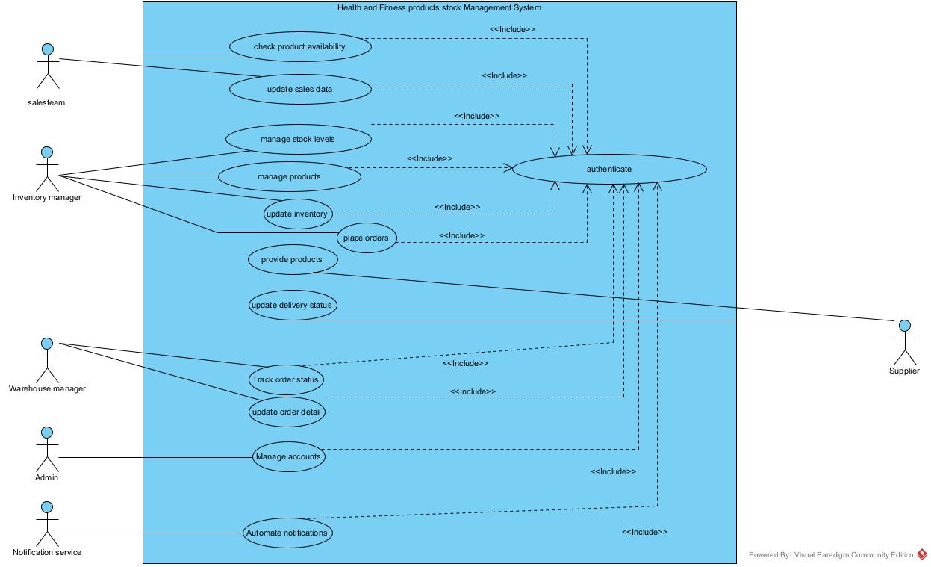

* 1. **SPECIFIC USE CASE DIAGRAMS.**

1. **For manage products.**

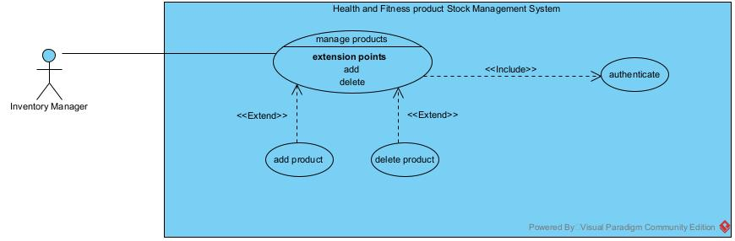

1. **For manage accounts.**

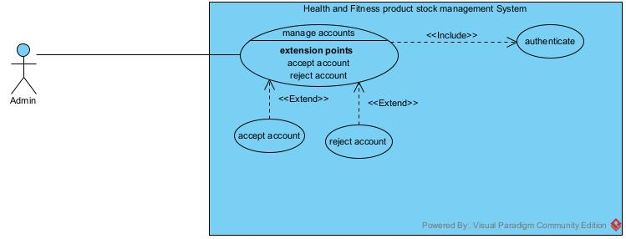

1. **ACTIVITY DIAGRAM.**

An activity diagram provides a behavior view of the system by describing the sequence of actions in a process or a particular activity. The activity diagram makes it possible to emphasize and to graphically formalize the sequence of actions carried out in the use case.

**2.1) ACTIVITY DIAGRAM OF AUTHENTICATION.**

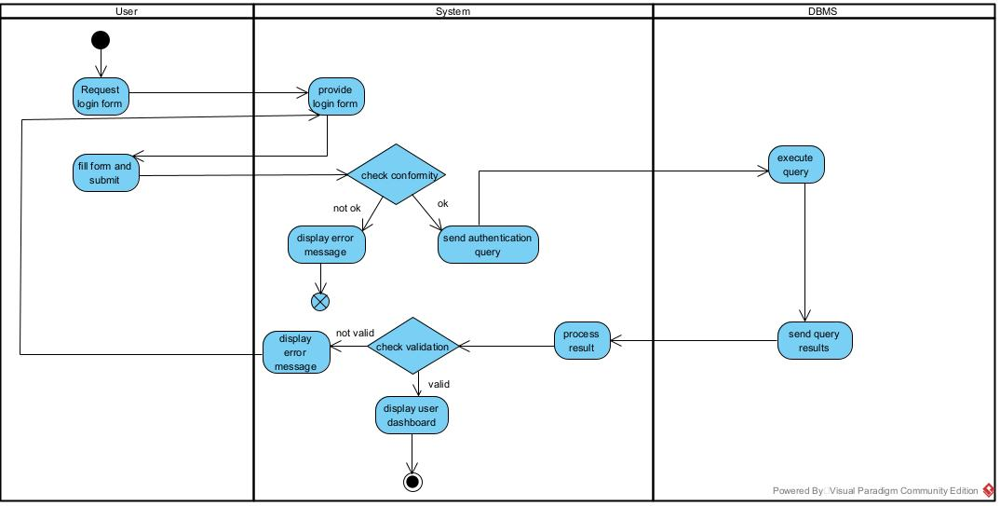

**2.2) ACTIVITY DIAGRAM OF INVENTORY MANAGEMENT.**

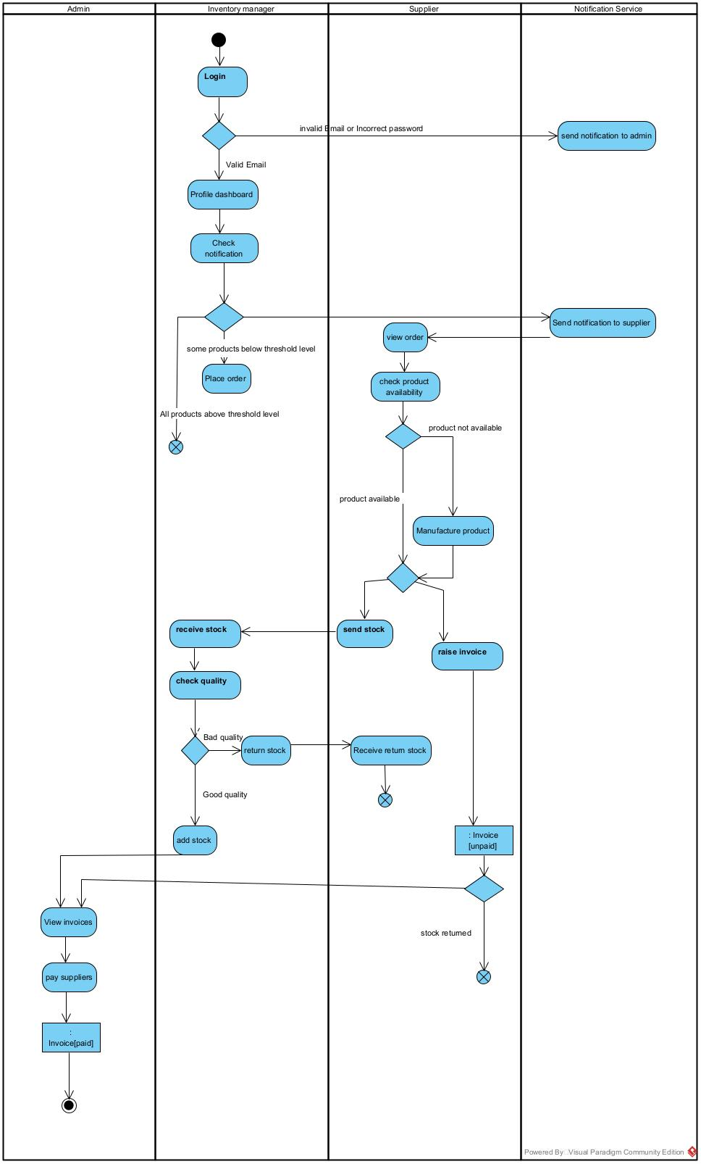

1. **SEQUENCE DIAGRAM (AUTHENTICATION).**

A sequence diagram is a UML diagram that illustrates the sequence of messages between objects in an interaction. It consists of a group of objects that are represented in life lines and the messages the exchange overtime during the interaction.

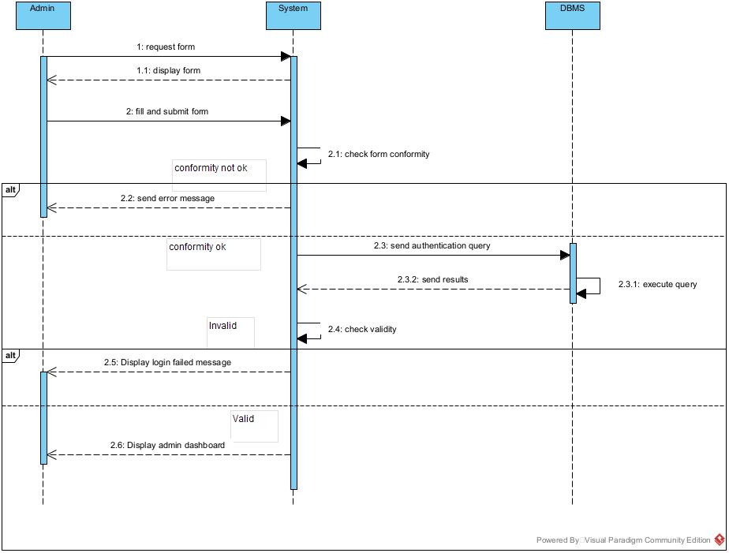

1. **COMMUNICATION DIAGRAM (AUTHENTICATION)**

Similar to a sequence diagram, it’s a diagram which models message forwarding using lifelines by numbering the sequences. The numbers represent the order in which messages are sent. On communication diagrams, objects are presented with connector association within them.

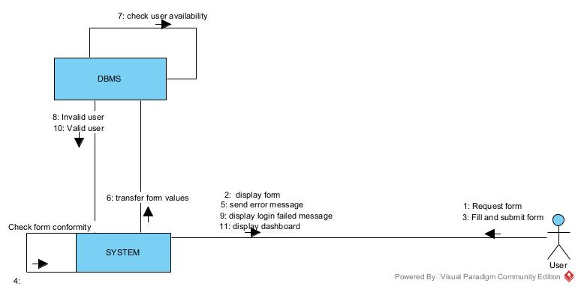

1. **STATE MACHINE DIAGRAM (LOGIN)**

It describes the internal behavior of an object. The present the possible sequences of states and actions that a class instance can process during its lifetime. A state represents a period in the life of an object during which it waits for an event and performs an activity.

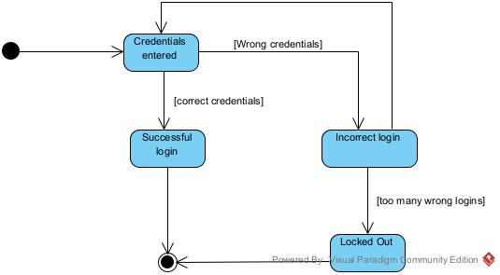

**IV.2 STATIC DIAGRAMS**

They describe the structure of the system in terms of system components (objects, classes, packages, component) and the relation between these components (specialization, association, dependency).

1. **CLASS DIAGRAM**

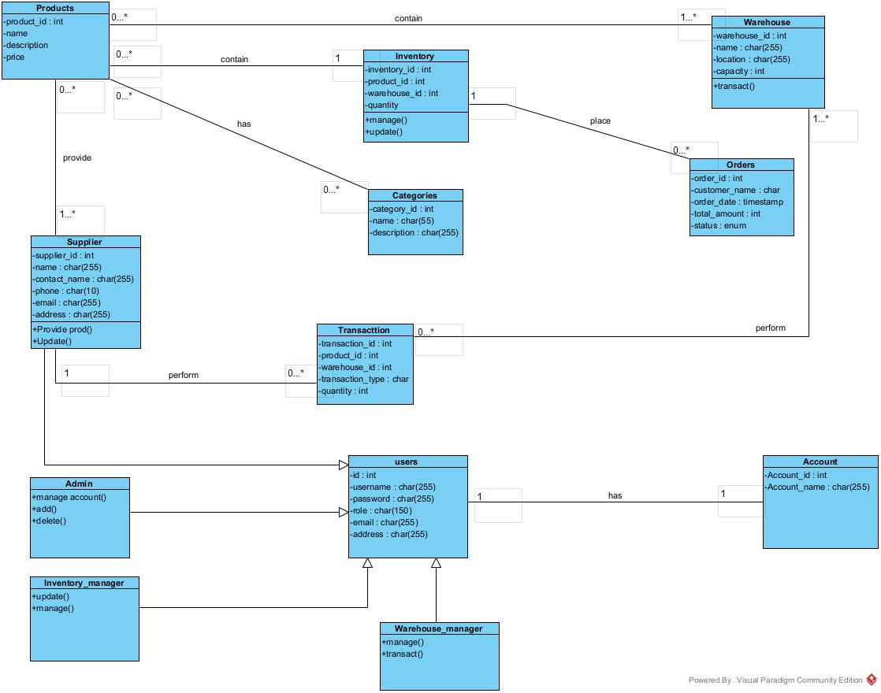 It expresses the static structure of the system in terms of classes and relations between these classes. Its purpose is to model the features of the information system. The class diagram is used to represent all the information that’s managed by the domain by describing what are the attributes and behaviors which it has rather than detailing methods to achieve operations.

1. **PACKAGE DIAGRAM.**

It allows the system to be broken down into more easily observable categories or parts called packages. A package serves the same purpose as a folder in computers.

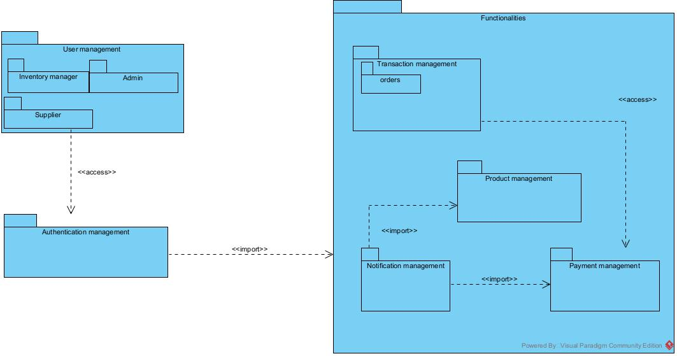

1. **DEPLOYMENT DIAGRAM**

It’s a type of diagram within UML that visually represents the physical deployment of software components onto hardware nodes. It shows the relationships between hardware and software elements in a system’s physical environment.

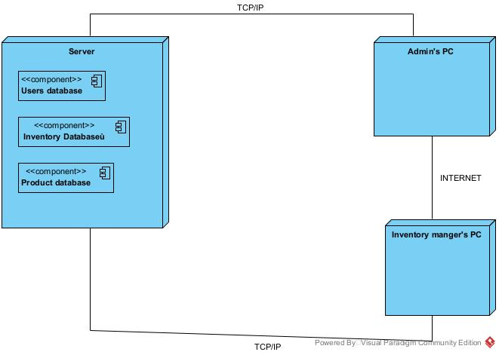

1. **COMPONENT DIAGRAM**

It is mainly used to describe dependencies between various software components such as dependency between source file and executable file. It represents the internal structure of the software (software component).

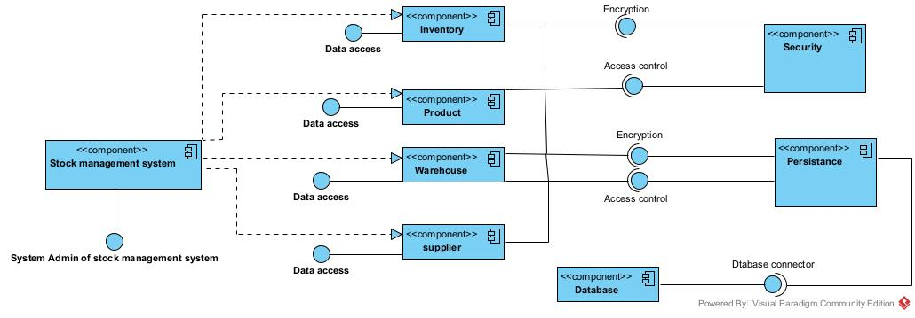v

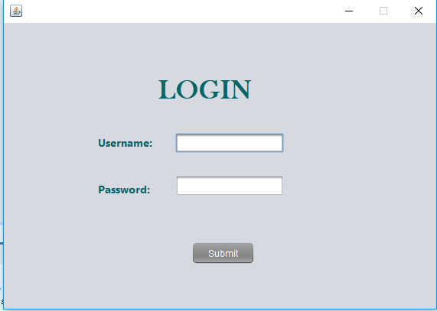**V. SOME SCREENSHOTS OF THE APPLICATION.**

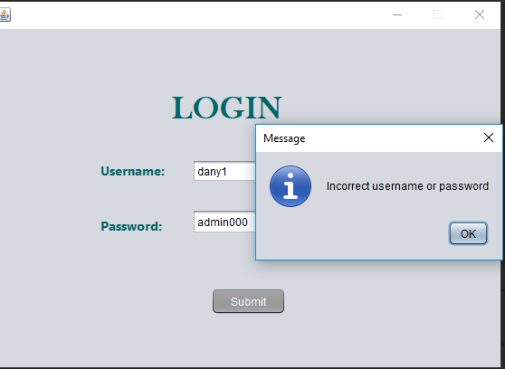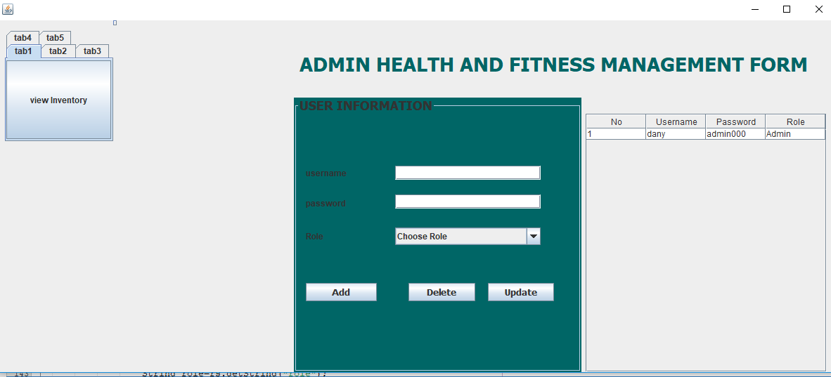

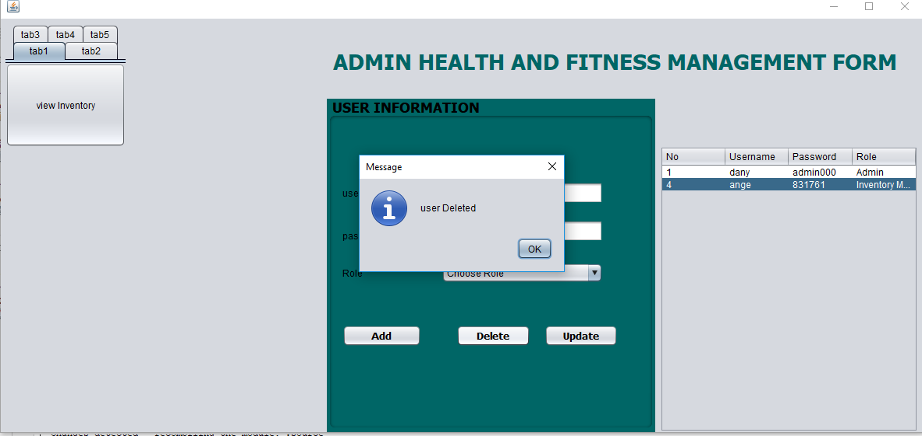

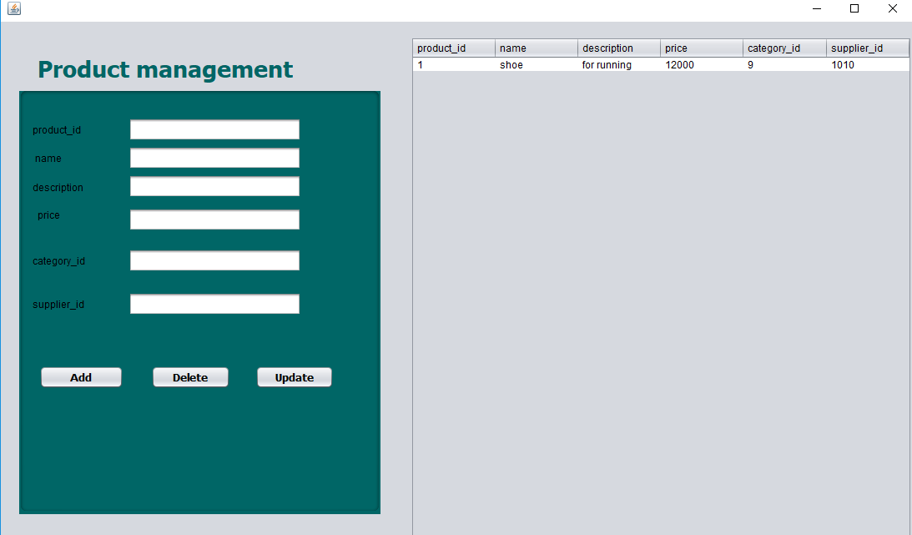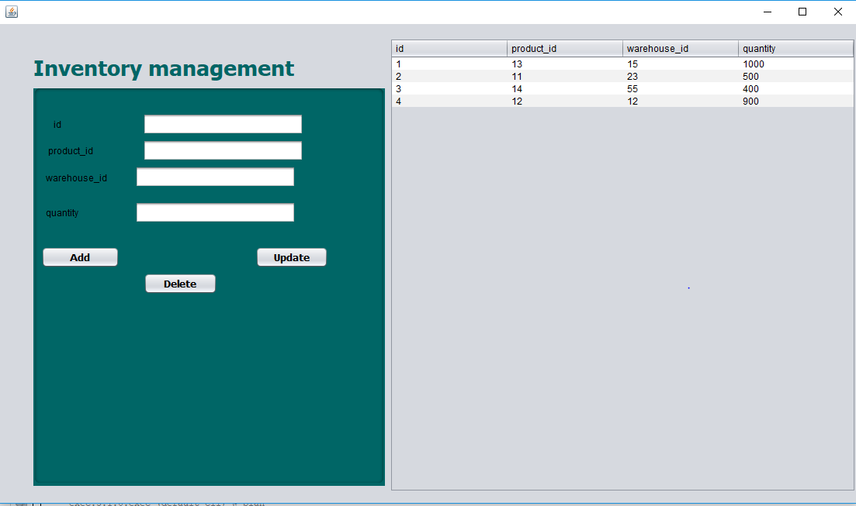

**V.1 CONCLUSION**

In conclusion, a robust stock management system is not merely a beneficial tool, but a necessity for businesses operating within the specialized and often complex health and fitness product market. These systems provide a critical foundation for success by addressing the unique challenges inherent in managing a diverse inventory that often includes variations in size, flavor, potency, and strict expiration dates. Ultimately, a comprehensive health and fitness product stock management system provides the data-driven insights and control necessary to navigate this competitive landscape, allowing businesses to focus on growth, customer satisfaction, and delivering quality products while maintaining profitability and regulatory adherence.